**CN vs MCIc**

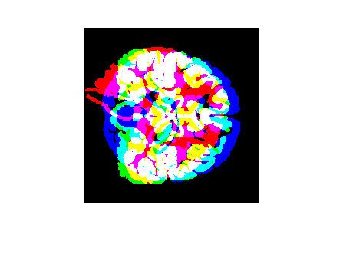

**Approach 1 - 2019_04_25_16_16**

**Network:**

Transfer learning from AlexNet changing last 3 layers.

|  |  |
| --- | --- |
| **Training parameters:**   * folds=3; * miniBatchSize = 20; * learningRate = 1e-5; * maxEpochs=20; * optimizer=’adam’; * "L2Regularization", 0.0001 * 'Shuffle','every-epoch' | **Dataset:**   * nSlices=6; * gap=2; |

**Results:**

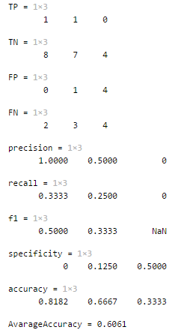

**Approach 2 - 2019_04_25_16_19**

**Network:**

Transfer learning from AlexNet changing last 3 layers.

|  |  |
| --- | --- |
| **Training parameters:**   * folds=3; * miniBatchSize = 20; * learningRate = 1e-4; * maxEpochs=20; * optimizer=’adam’; * "L2Regularization", 0.0001 * 'Shuffle','every-epoch' | **Dataset:**   * nSlices=6; * gap=2; |

**Results:**

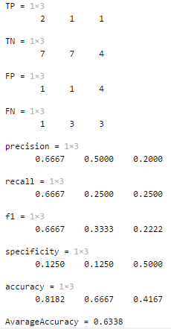

**Approach 3 - 2019_04_25_16_22**

**Network:**

Transfer learning from AlexNet changing last 3 layers.

|  |  |
| --- | --- |
| **Training parameters:**   * folds=3; * miniBatchSize = 10; * learningRate = 1e-4; * maxEpochs=20; * optimizer=’sgdm’; * "L2Regularization", 0.0001 * 'Shuffle','every-epoch' | **Dataset:**   * nSlices=6; * gap=2; |

**Results:**

